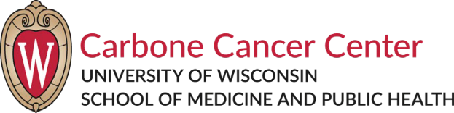

The Breast Cancer Research Advisory Network (BCRAN)
Wednesday, May. 13, 2020 ~ 6:00-7:30 pm The Wisconsin Institutes for Medical Research
1111 Highland Avenue, Room 7001A

Virtual Meeting Agenda

WebEx link:
https://uwmadison.webex.com/uwmadison/j.php?MTID=m7333309789c453e1f02c5abd8cede5d2

Introductions & Announcements
Lisa Arendt, DVM, PhD
Presentations
Josh Lang, MD MS

Presenting on the Research of CTCs and liquid biopsies and how these methods apply to breast cancer

Closing Discussion
BCRAN Annual Travel Scholarship Announcement
“Be the Cure” Silent Auction Volunteers
BCRAN Outreach Pamphlet project

Save the Dates
Wednesday, September 9, 2020
Wednesday, November 11, 2020

