- The online portal, Outreach (Psyche), for Wisconsin State Laboratory of Hygiene (WSLH) can be used to request/order a PMMTB consult and to view, print and save copies of recommendations from presented cases. The program has been tested to be compatible using Internet Explorer (or some versions of Firefox).
  - The Outreach website address is https://www.med.wisc.edu/uwcgc
    - Then click on the Online Portal Access tab located on the left-hand side of the screen.
    - If you have a valid Outreach user ID and password, click on the Log onto Outreach (Psyche) link and that will bring up the log-in screen.
      - If you do not have a valid user ID or password, click on the Web Portal Authorization Request for WSLH Partners and Clients link. This will bring up a form that you will need to fill out and fax to UW Cytogenetic Services and Molecular Genetics to obtain a valid user ID and password. Once you obtain your user ID and password, then you can click on the Log onto Outreach (Psyche) link.
  - Outreach can only be accessed by entering a valid user ID and password. Enter your user name and password, and then click Log In. Three consecutive login attempts with an incorrect password will disable the user account. Once an account has been disabled, it must be reset by the Outreach System manager at WSLH.
  - Each user will need to read and accept the HIPAA authorization before first using the site and once per year thereafter.
- 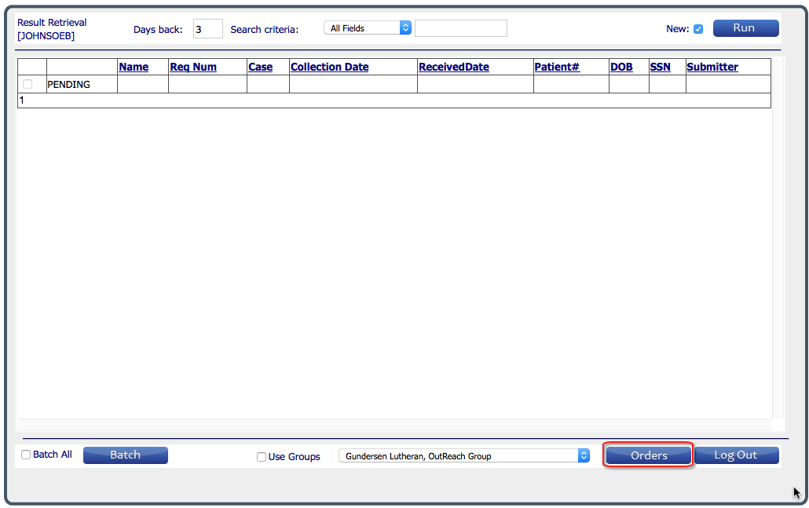The program opens to the Results Retrieval window (to order tests, click on the Orders button in the lower right and see section III below)
Figure 1 Results Retrieval
  - To display a list of cases with results, click on the Run button. This will load all cases that were signed out within the past 7 days as well as pending cases (cases that have been accessioned by the cytogenetics lab, but that are not complete).
    - The Days back can be changed to look for cases signed out in a shorter or longer time frame, then click Run again.
    - The case list is sorted alphabetically by patient, to sort by a different field click on the column heading.
    - To further narrow the list of results, additional search criteria may be used; select a field to search and then enter the specific criteria.
  - To view a report:
    - To see a single report, click on View Report. The pdf of the case report will be displayed. The report may be printed from this window or saved to an electronic file (the file will need to be renamed when being saved).
    - To see multiple reports, click in the box in front of View Report for each patient and then click Batch. All of the reports will be displayed in a single file. The reports may be printed from this window, but if saved all reports will be compiled into a single file.
    - To return to the Results list, click on Results in the upper left corner.

- 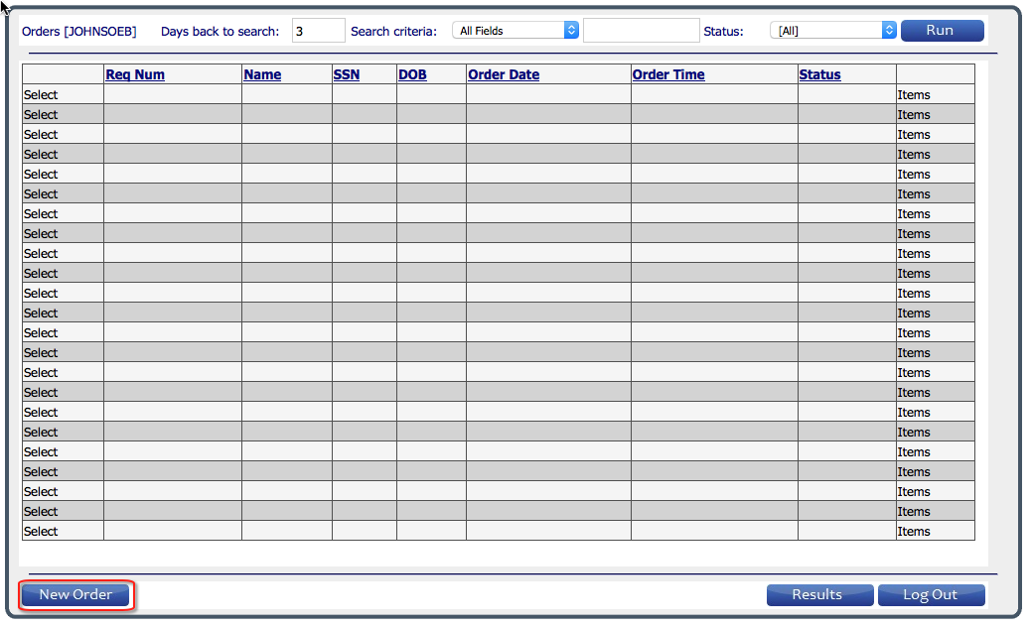The Orders window will be displayed when the user clicks Orders in the lower right.
  - To order testing on a patient, click on New Order in the lower left corner (see figure 2).
Figure 2 Orders window
    - The submitting clinician is selected by clicking Set Submitter (see figure 3). An alphabetical list of physicians associated with the ordering location is displayed. To search, enter part or all of the clinician’s name into the Search Criteria field, and click Run. Click on Select to the left of the clinician’s entry. Mode should be “Pathology”
      - 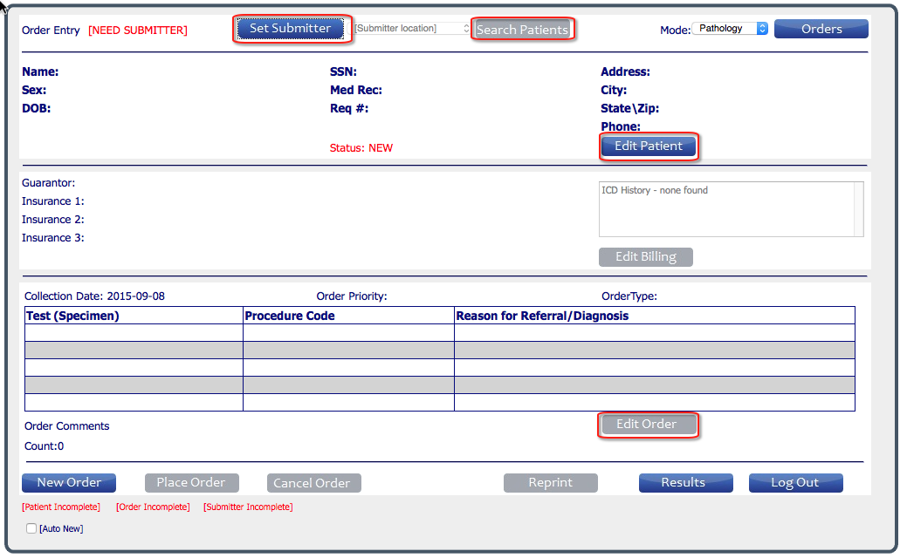Note: the selected clinician will be used as the default Submitter for additional orders placed unless Set Submitter is used to select a new clinician.
Figure 3 Order entry window 1
    - If testing on the patient has been ordered in the past, click on Search Patients to find the patient entry and then click Select, or click Edit Patient to create a new entry (also used to modify/update information in a patient’s entry). (see figure 3)
      - Patient name must be entered as Last, First
      - Patient DOB must be entered as YYYY-MM-DD or use the calendar feature
    - To order tests for the patient, click on Edit Order (figure 3), the second order entry window opens (see figure 4).
      - Fields with * must be filled
      - Select the Order Type (Molecular Tumor Board Request)
      - Collection date defaults to current date, but can be modified.
      - 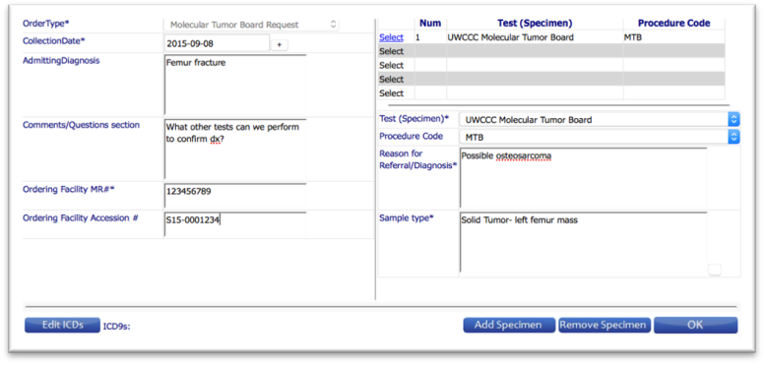Select test to be ordered from the pull down list (UWCCC Molecular Tumor Board). The Procedure code will load automatically.
Figure 4 Completed order window example
      - Sample type may be selected from list (click on the small button immediately to the right of the field) or free texted.
      - To order multiple tests, fill in all fields for the first test, and then click Add Specimen. Fill in all fields (may use “same” for Reason for Referral).
      - If Questions is displayed on the lower left, click on Questions and select the appropriate response; the order cannot be placed until the question is answered.
      - Click on OK to save all entries and return to the Order Entry window.
    - Click on Place Order (see figure 3 – lower left), this will open a dialog window to print the requisition form to send in with the specimen. The Status will change from New to Open.
    - After the specimen has been received and accessioned by the cytogenetics lab the status will change from Open to Accessioned. Orders may be edited or cancelled through Outreach only until they have been accessioned by the cytogenetics lab.

  - To display a list of cases that were ordered within the past 7 days, click on the Run button (see figure 2). The Days back can be changed to look for cases ordered in a shorter or longer time frame, then click Run again.
    - The case list is sorted alphabetically by patient, to sort by a different field click on the column heading.
    - To further narrow the list of results, additional search criteria may be used; select a field to search and then enter the specific criteria.
    - To return to the Results Retrieval window, click on Results.

For questions or concerns regarding the Online Portal Access, please contact:

UW Cytogenetic Services and Molecular Genetics
465 Henry Mall, Room 419 Madison, WI 53706
cytogenetics@mail.slh.wisc.edu
(608) 262-0402 or (800) 862-1013
Secure Fax: (608) 265-7818

